Comments….
Overall the questionnaire is looking great!

Have cut and pasted pages providing tracked changes.
Most important general comment is that we want to drive respondents to our website and to outside treatment for instructions for sleep education, specific guidance and ultimately clinical intervention. All report content should be diagnostic only and next steps for further diagnosis and recommendations and include no advice. I am making comments throughout that will guide this.
At the moment the diagnostic speficis look pretty good. We may want to calculate or discuss cutoff off scores for each of the primary sleep disorders that will be addressed in the report. This will be super helpful in the future if we need to make minor algorithm adjustments after we collect psychometric data.

There is an issue with leading 0’s when there are prompts to enter numbers. This is not a big issue. Just a little awkward.
Move all prompts for diagnosis of sleep disorders to top. Start with..have you been diagnosed with a sleep disorders? IF yes…then a list of disorders with check boxes: Currently they are at the end and the narcolepsy hypersomnia is on page 3.
Narcolepsy
Hypersomnia
Insomnia
Parasomnia (sleep walking or sleep terrors)
Nocturnal enuresis (bedwetting)
Circadian rhythm disorder
Restless Legs Syndrome and/or periodic limb movement disorder
Obstructive sleep apnea Syndrome
Central Sleep Apnea Syndrome
Insufficient sleep
Rem Behavior Disorder

Intro Page

Questionnaire: 15-20 Minutes
Complete at your own pace with progress saved automatically and a free personalized report with recommendations provided.

We Evaluate Nighttime & Daytime
Your day and nighttime habits with so that we can support your health and well beingQuestions about your sleep patterns, daily energy, attention, and happiness

Free & Anonymous Report
You will receive a free and personalized anonymous report with specific guidance on your next steps to improve your sleep health or address a probable sleep disorder.

Expert Guidance

Our website provides with you essential science based sleep information and will guid you toward the net steps to imporive your sleep health and well being.

Recommendations are provided by our board certified sleep doctors.
Your Privacy is Protected
The information provided will be de-identified and not linked to you unless you choose to receive services from our sleep experts. We are bound by federal and state laws to protect your privacy.
Before You Begin

P. 1

Age-Related Sleep Changes
Sleep naturally change with age. After 55, it's common to experience:
- Increasingly Earlier bedtimes and wake times
- More frequent nighttime awakenings
- Perceiving sleep as lighter and more disrupted

These changes are normal and you will receive personalized guidance in the sleep report to improve your sleep health and quality of life.

Prior to the age of 25 there is biological tendency for adelayed sleep phase, a preferrnce to stay up late and wake up late. This may conflict with school or work schedules. If you're struggling with early morning obligations, you can shift your schedule. In your sleep report you will receive guidance on next steps to maintain a healthy schedules that does not interfere with you daily activities and improves your sleep health and quality of life.
For Women >45 years of age. Sleep disturbance in women in your age group is often related pre-and perimenopausal home related changes. We wll provide you with specific information and guidance regarding these changes.
Page 3 –
Do you take planned naps. If yes….
How many and how long
How long is the average nap
How many days a week do you nap.

Add to Page 3 –
If yes to cataplexy questions (strong emotion and laughing – any positive heare or a score greater than) or a score greater than six on the likelihood of falling asleep questions then add a pop-up: “You have signs and symptoms of excessive daytime sleepiness, Narcolepsy or idiopathic hypersomnia. We will provide guidance on next steps in your report. Please be aware that these disorders can increase risk of injuries and car accidents.”

Rate how you feel during the day

Page 4 and 5

Suggest making all times and am/pm forced choice throughout

what time do you wake up in the morning

Page 6

Based on your responses, we will provide important information in the report which will include discussion of treatment options with your sleep specialist or primary care doctor. Sleep breathing disorders can significantly impact your health.

Page 7

Please answer the following about sensations in your legs and arms at bedtime:

RLS questions [ agree that one affirmative should trigger pop up]:

I have uncomfortable sensations in my legs and arms while lyng in bed,

I have an urge to move my legs and arms while lying in bed

[additional questions can be nested]

Movement temporarly removes sensations]

[daytime question can trigger stronger rec in report to see a neurologist as this can be due to more severe symptoms or a side effedt of RLS treatment]

Your answers suggest that you may have restless legs syndrome. We will make additional recommendations in your report and provide specif guidance and treatment recommendations on our website.

Page 8

Parasomnias are unusual behaviors during sleep that can affect your safety and sleep quality. These include sleepwalking, , night terrors, eating and acting out your dream,

Have you been told that during your sleep period engage any of these behavioras and have no memory of them: (check all that apply)

In list, replace talk with eating

In sublist – add, have you been injurned or tried to leave your home during one of these events [this can triger a high risk warning]

Move “I have been diagnosed – either rto the beginning or end of the questionnaire.

Page 10:

Change title to Sleep Schedule Preferences

Cut past shift work question.

Morning Person Chronotype
You have an early chronotype preference. Waking earlier than desired and experiencing evening sleepiness that interferes with activities, are symptoms of Advanced Sleep Phase Syndrome. These may increase after the age of 55. More details will be provided in the report with links to education and recommendations on our website.

Night Owl Chronotype
You have a late chronotype preference. Difficulty waking in the morning, daytime tiredness and difficulty falling asleep are symptoms ofDelayed Sleep Phase Syndrome. This is particularly common between ages 12-25 but can affect all ages. Consider consulting with a sleep specialist if these issues impact your daily functioning. More details will be provided in the report with links to education and recommendations on our website.

Page 11:

Understanding what medications and supplements you take helps us provide better recommendations. Some substances can significantly impact your physical and sleep health.

Add other tab with option for write in for both supplements and prescription.

Prescription Sleep Medications
Long-term use of sleep medications can lead to dependence and may mask underlying sleep disorders.Your sleep report will include links and next steps for healthy management of these medications.

Multiple Sleep Aids Detected
You're using multiple sleep aids, which may indicate significant sleep difficulties. This combination approach can lead to interactions and side effects. Your sleep report will include links and next steps for healthy management of these medications.

Page 13

High Caffeine Intake
You're consuming more than 4 caffeinated beverages per day. High caffeine intake can lead to increased anxiety, disrupted sleep, and dependency. In your personalized report we will provide links to our website and for information on managing managing caffeine consumption.

Add to alcohol pop up - In your personalized report we will provide links to our website and for information on managing managing caffeine consumption. Recent evidence suggests that alcohol consumption can contribute to cancer or other significant health complications.

No Regular Exercise
Regular exercise is one of the best ways to improve sleep quality and general health. Even moderate exercise like a 30-minute walk can significantly improve sleep. In your personalized report we will provide links to our website and other sites to develop an exercise plan that is right for you. \

Page 14

Mental Health Resources
If you're experiencing anxiety, depression, which can include excessive worry and avoidance of usual daily activities or other mental health concerns , remember that help is available. Mental health professionals can provide evidence-based treatments that address both sleep and emotional well-being. In your personalized report we will make specific recommendations for next steps for relieving your suffering.

Sleep-Related Anxiety Detected
It's likely that your anxiety related to sleep is interfering with your ability to sleep at night. This creates a vicious cycle where worry about sleep prevents sleep, which increases worry.

Your personalized sleep report will provide you with links to our website and other resources to receive help and to alleviate your suffering.

Report

Thank you for completing the SomnaHealth comprehensive sleep questionnaire. With more than 4 decades of collective experience, our team created the questionnaire and personalized report to provide you with guidance on improving your sleep health.

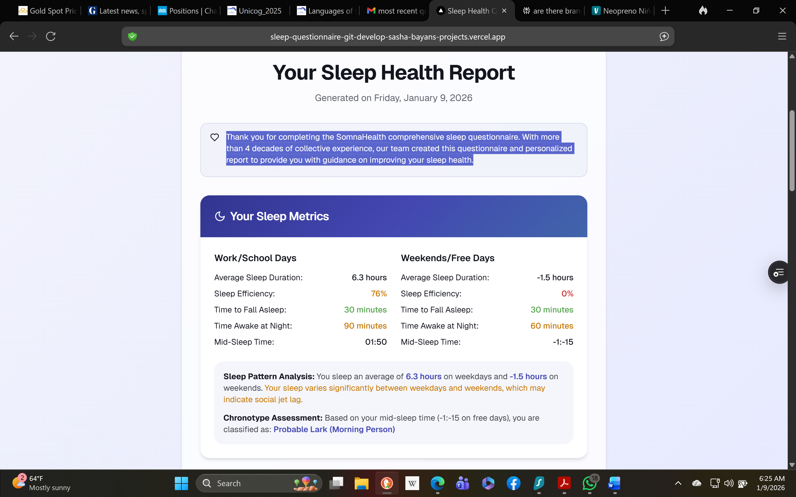

Calculations are a bit off. Suggest adding a total calculations – (while this may be unnecessary for consumer it will be super valuable to providers and particulary sleep specialists). This can be a weighted average of the same variables 5x workday results +2x weekend freedays/7. Please also add variables: Social Jet Lag which includes Cathcup up sleep on weekends [>1.5 hours = insufficient sleep during the week] and mid-sleep time change greater than +1 hour = catch up sleep and propensity for a later/owl chronotype.

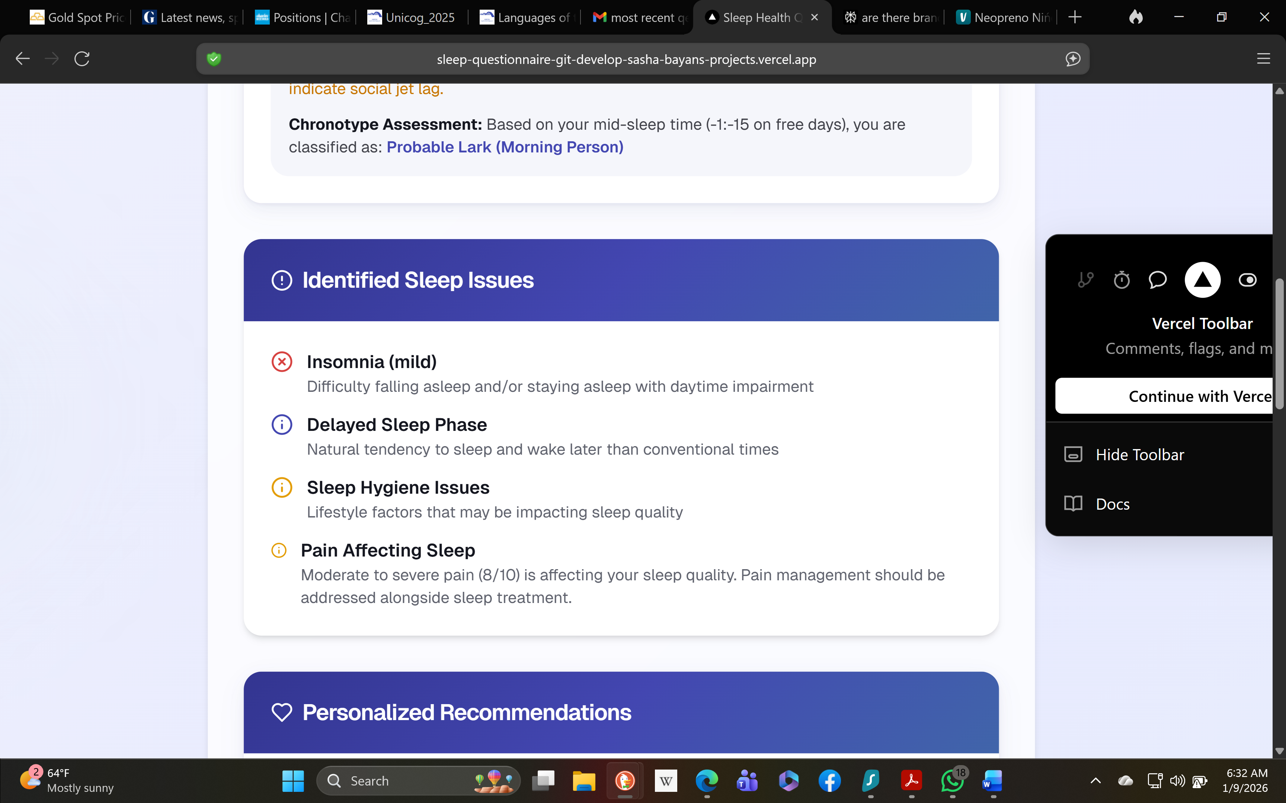

need to check data as above says lark and belowy says deleay. Also suggest adding specific to sleep hygiene or at least (see details below)

We will want to cut all recommendations and instead provide links to our website and out outside professional organization with links to providers in their area.

e.g…..below is generic rec. For all disorders except for:

Hypersomnia and parasomnias which should safety warnigns:

Your responses to questions on [daytime sleepiness, parasomnias] suggest that you may have a sleep disorder that places you, family members and other at risk of injury that could include automobile or sports accidents.

Your daytime sleepniness symptoms are signfcant and we suggest that you exercise significant caution that might include avoiding driving, biking or other high risk activities until you are treated. More and specific recommendations are on our website [link out]

Your parasomnias – sleep walking, sleep eating or night terrors (when they have attempted to leave the house, eat or have been injured) place you at significant risk of injury. We strongly recommend that someone in your home monitor your behavior at night and only wake you if you try to leave your home or are at risk of other injury. Please seem more information here about safety precautions [link out].

Your use of sedating medications and alcohol can increase your risk of falls or other injuries at night. We suggest that you exercise caution by asking someone in your home for assistance, using nightlightes through out your home.

Your use of [prescriptions and/or caffeine and/or alcohol] are significant and can lead to health risks and injury and support and management by specilaised provider is recommended. We provide additional information on our website [link out], but you should consult with your prescribing provider or other health professional before making changes as there can be side effects when you discontinue use.

You have endorsed symptoms of [include all sleep disorders] \ These diagnoses are interfering with your daytime functioning. We provide more detail on our website for [link out to sleep principles, health sleep practices, and specific sleep disorder] and strongly recommend that you bring this report to your health care provider. You can find a provider on our website or links to providers in your area.

In resources -- - just provide links to our website……for relevant disorders or sleep health problems.

